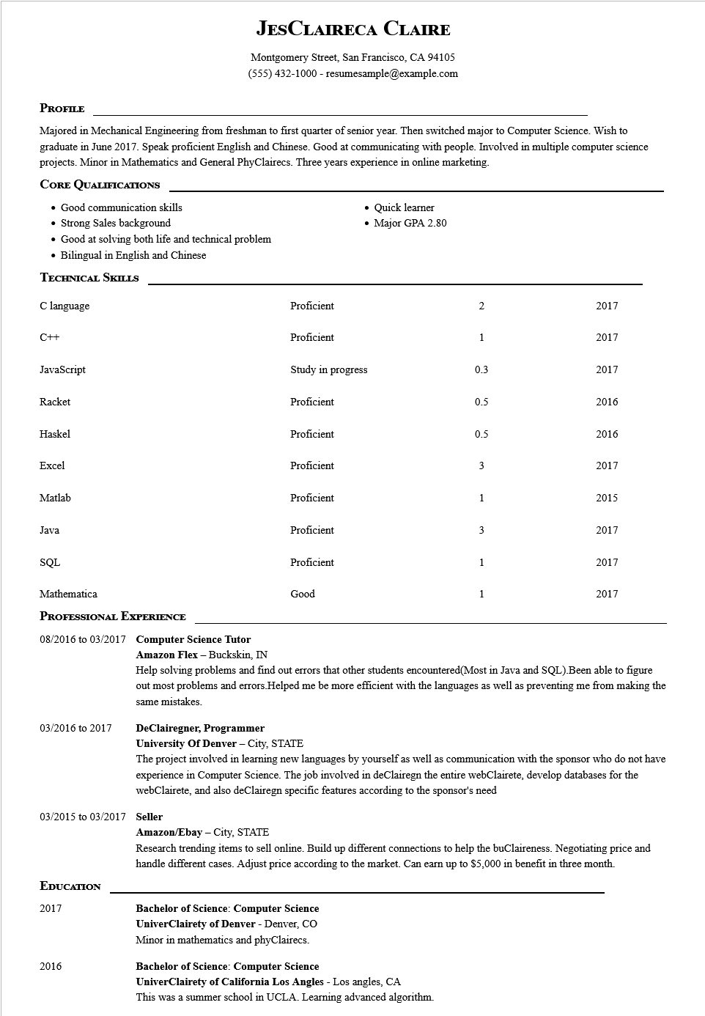
JESCLAIRECA CLAIRE
Montgomery Street, San Francisco, CA 94105 (555) 432-1000 - resumesample@example.com
PROFILE
Majored in Mechanical Engineering from freshman to first quarter of senior year. Then switched major to Computer Science. Wish to graduate in June 2017. Speak proficient English and Chinese. Good at communicating with people. Involved in multiple computer science projects. Minor in Mathematics and General PhyClairecs. Three years experience in online marketing.
CORE QUALIFICATIONS
• Good communication skills
• Strong Sales background
• Good at solving both life and technical problem
• Bilingual in English and Chinese
TECHNICAL SKILLS
C language
C++
• Quick learner
• Major GPA 2.80
2
2017
1
2017
Proficient
Proficient
JavaScript
Study in progress
0.3
2017
Racket
Proficient
Haskel
Proficient
0.5
2016
0.5
2016
Excel
Proficient
3
2017
Matlab
Java
SQL
Mathematica
PROFESSIONAL EXPERIENCE
08/2016 to 03/2017 Computer Science Tutor
Proficient
1
2015
Proficient
3
2017
Proficient
1
2017
Good
1
2017
03/2016 to 2017
Amazon Flex - Buckskin, IN
Help solving problems and find out errors that other students encountered(Most in Java and SQL).Been able to figure out most problems and errors. Helped me be more efficient with the languages as well as preventing me from making the same mistakes.
DeClairegner, Programmer
University of Denver - City, STATE
The project involved in learning new languages by yourself as well as communication with the sponsor who do not have experience in Computer Science. The job involved in deClairegn the entire webClairete, develop databases for the webClairete, and also deClairegn specific features according to the sponsor's need
03/2015 to 03/2017 Seller
EDUCATION
2017
2016
Amazon/Ebay - City, STATE
Research trending items to sell online. Build up different connections to help the buClaireness. Negotiating price and handle different cases. Adjust price according to the market. Can earn up to $5,000 in benefit in three month.
Bachelor of Science: Computer Science
UniverClairety of Denver - Denver, CO Minor in mathematics and phyClairecs.
Bachelor of Science: Computer Science
UniverClairety of California Los Angles - Los angles, CA
This was a summer school in UCLA. Learning advanced algorithm.

